TASK 4 DOCUMENTATION

Project Title
Data Visualization on Dataset for Data Analytics

Abstract
Data Visualization is an important phase of data analytics that helps convert raw data into meaningful graphical representations. This project focuses on visualizing various aspects of the cleaned dataset to identify trends, patterns, relationships, and outliers. Different visualization techniques were used to analyze customer behavior, product performance, sales trends, payment preferences, and referral sources. The visualizations provide valuable insights that support effective decision-making and business analysis.

1. Introduction
Data visualization enables analysts to understand complex datasets through graphical representations. Visual analysis helps identify trends, distributions, relationships, and anomalies that may not be easily observed through raw data alone.
This project involves creating multiple visualizations using Python libraries such as Matplotlib and Seaborn to explore the Cleaned Dataset for Data Analytics and derive meaningful insights.

2. Objectives
- To analyze sales trends and customer behavior.
- To evaluate product performance and revenue contribution.
- To identify patterns and relationships within the dataset.
- To detect outliers through visual analysis.
- To communicate insights effectively using graphical representations.

3. Problem Statement
Organizations generate large volumes of data from customer transactions and business operations. Understanding this data through visual analysis helps uncover important trends and patterns. The objective of this project is to create meaningful visualizations that simplify data interpretation and support data-driven decision-making.

4. Dataset Description
Dataset Name: cleaned_dataset
The cleaned dataset obtained after the Data Cleaning and Exploratory Data Analysis phases was used for visualization. Various charts and plots were generated to analyze customer behavior, sales performance, revenue contribution, and relationships among variables.

Dataset Information
- Dataset Namecleaned_dataset
- File Format: Excel (.xlsx)
- Domain: Data Analytics
- Purpose: Data Visualization

5. Tools and Technologies Used
- Jupyter Notebook
- Python
- Pandas
- Matplotlib
- Seaborn
- Microsoft Excel

6. Methodology

Step 1: Data Loading
The cleaned dataset was imported into Jupyter Notebook using Pandas.

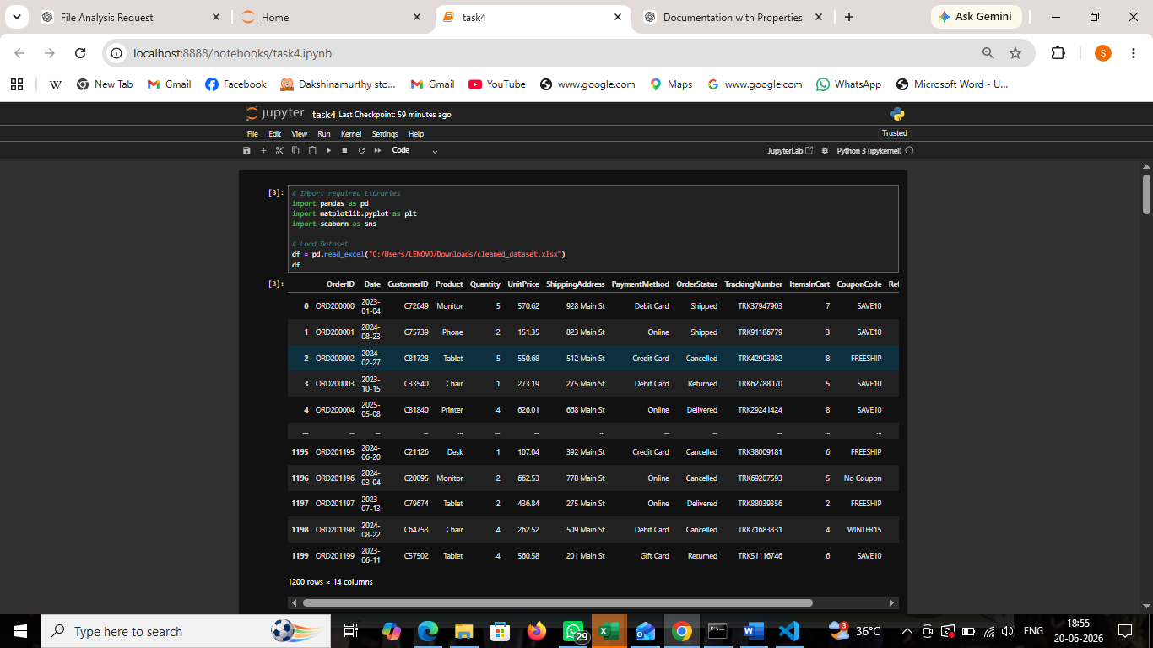 Step 2: Data Visualization
Different visualization techniques were applied to analyze the dataset and generate insights.

7. Data Visualization Tasks Performed

7.1 Order Status Distribution
- Visualized the frequency of different order statuses.
- Identified the most common order status.
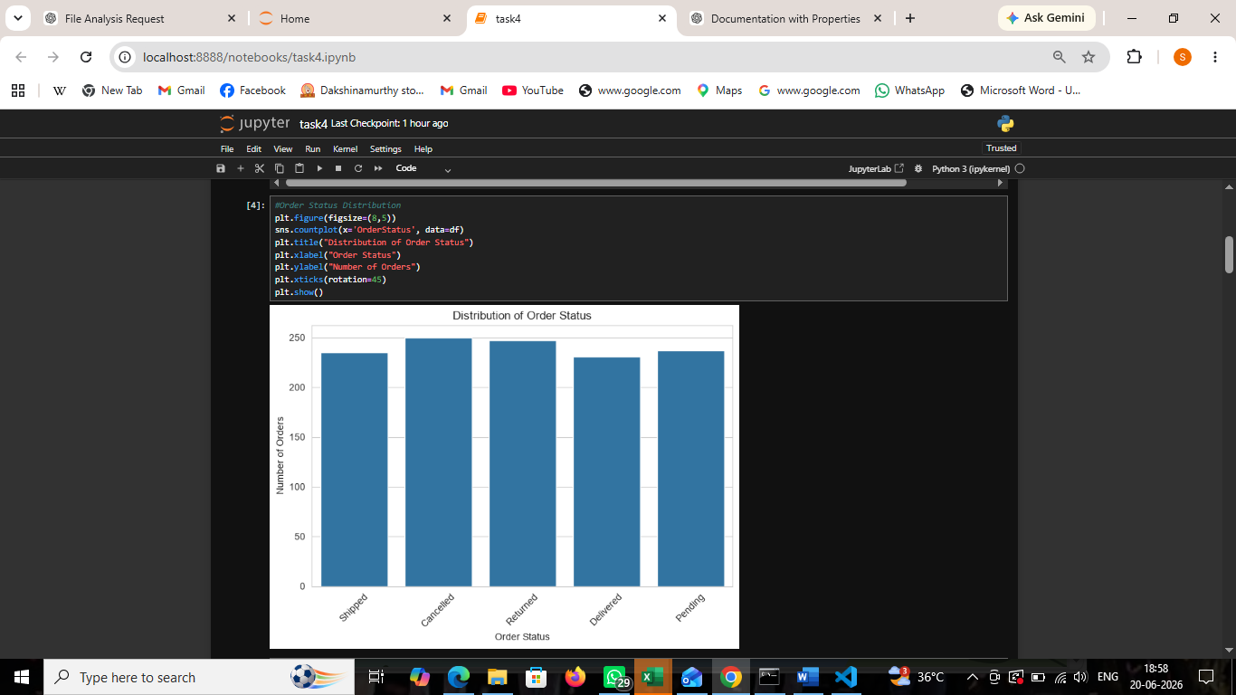)

7.2 Payment Method Usage
- Analyzed the usage frequency of payment methods.
- Identified the most preferred payment method.

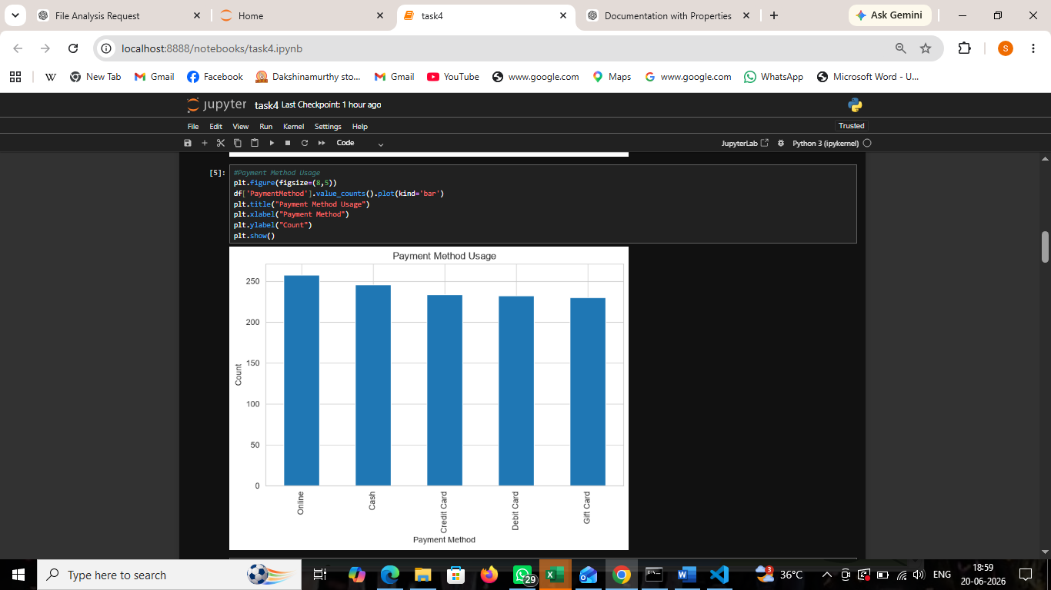

7.3 Top Selling Products
- Compared product sales quantities.
- Identified the best-selling products.

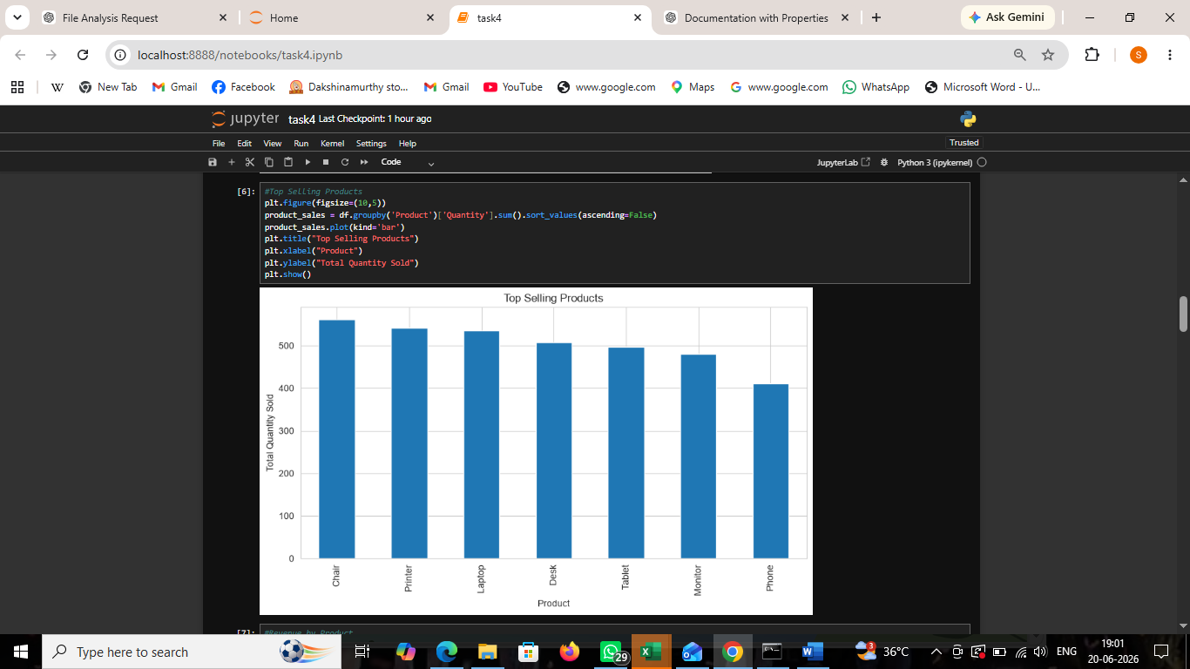 7.4 Revenue by Product
- Analyzed revenue generated by each product.
- Identified products contributing the highest revenue.

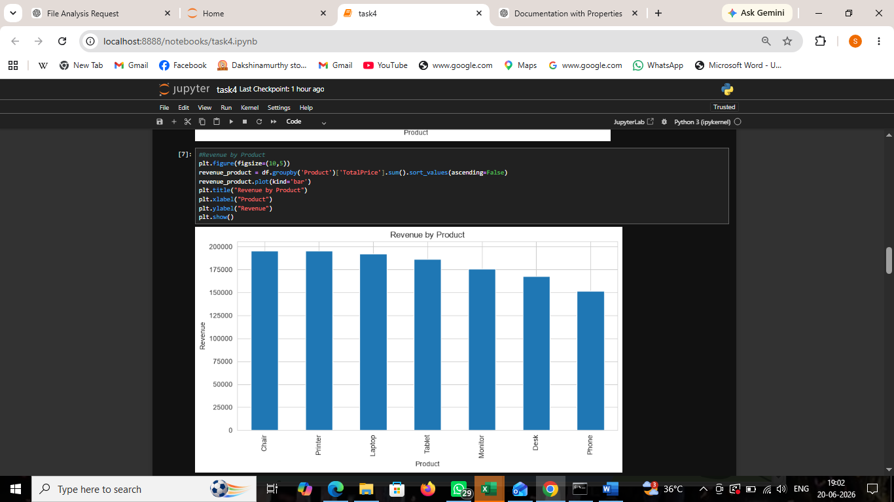 7.5 Monthly Sales Trend
- Examined monthly revenue patterns.
- Identified trends and fluctuations in sales.

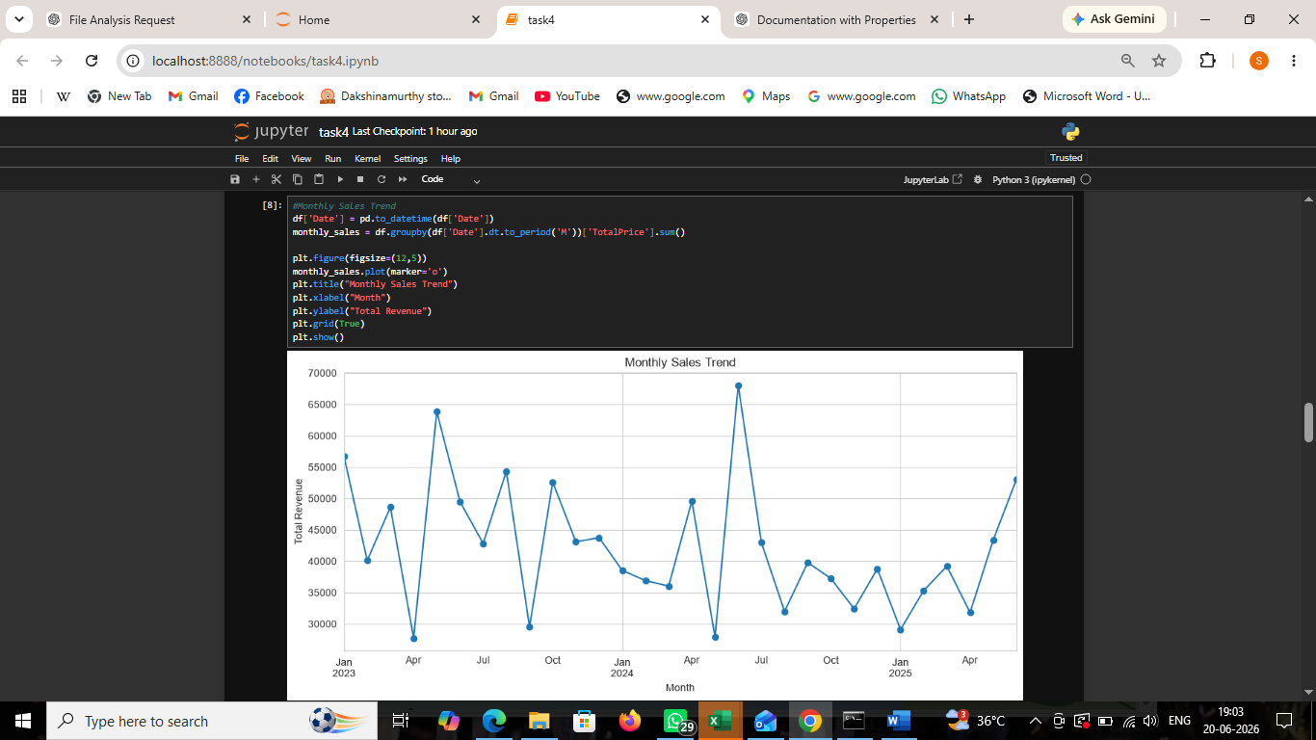

7.6 Referral Source Analysis
- Analyzed customer referral sources.
- Identified channels contributing the highest number of orders.

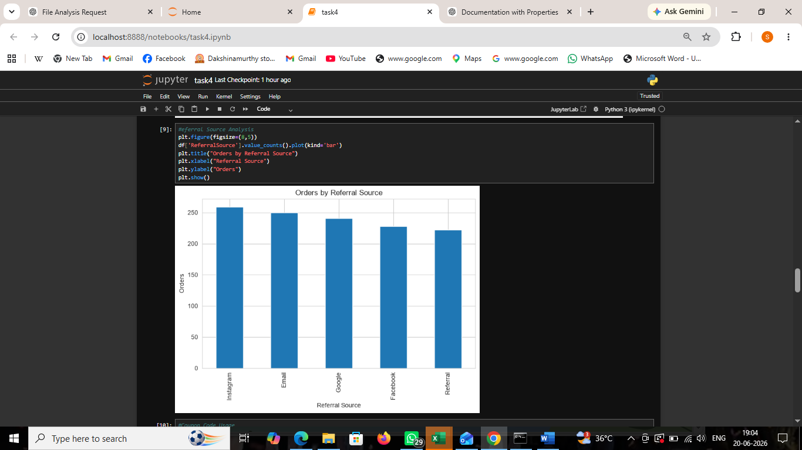 7.7 Coupon Code Usage
- Visualized coupon code utilization.
- Compared the popularity of different coupon codes.

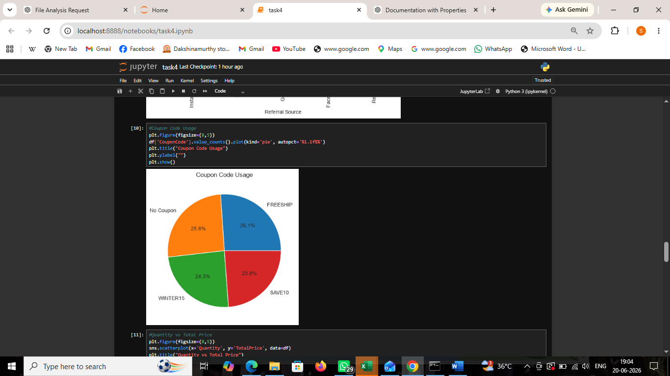 7.8 Quantity vs Total Price Analysis
- Examined the relationship between quantity purchased and total price.
- Identified patterns and possible correlations.

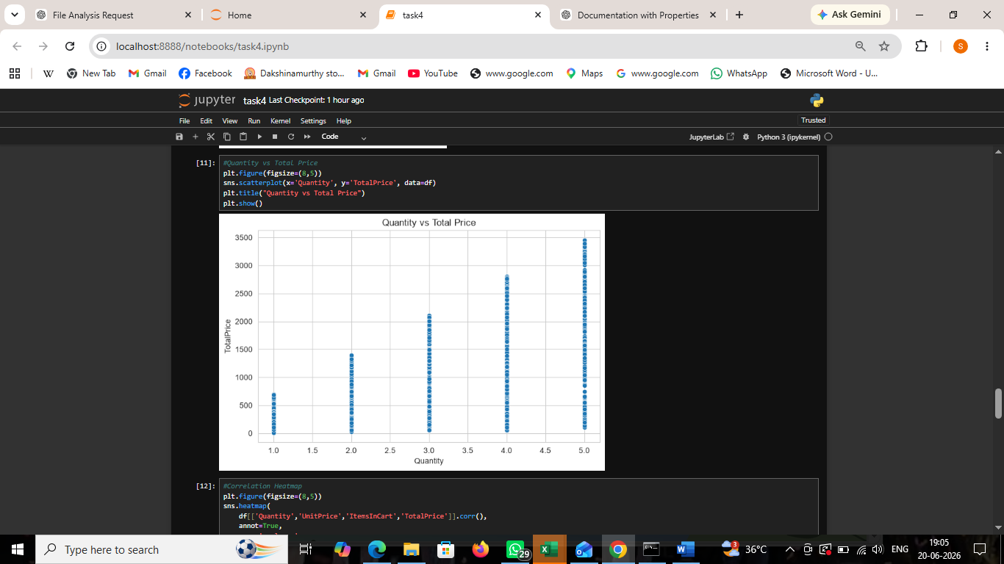

7.9 Correlation Heatmap
- Analyzed relationships among numerical variables.
- Identified strong positive and negative correlations.

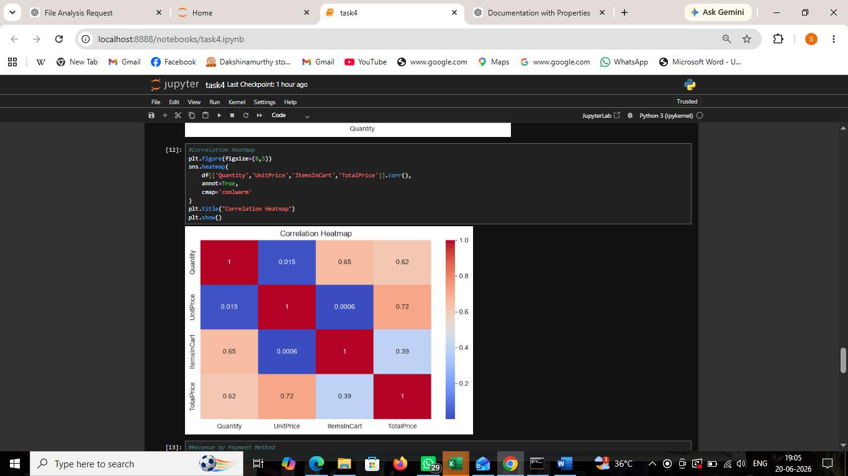 7.10 Total Price Distribution (Box Plot)
- Detected potential outliers in total price.
- Examined the distribution of transaction values.

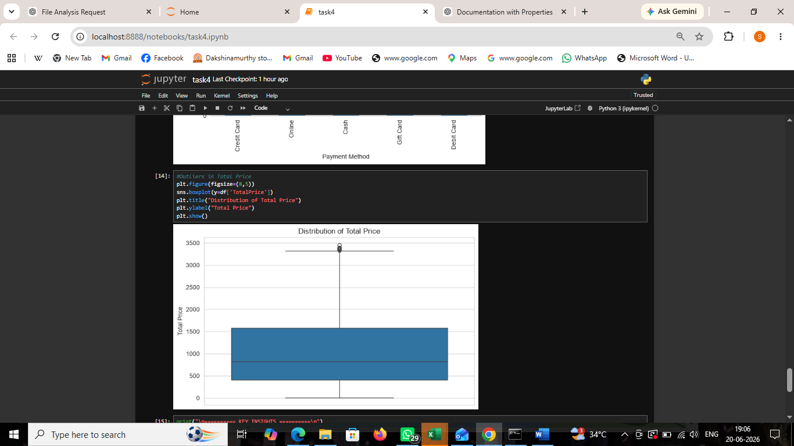 8. Results
The visualization analysis successfully revealed:
- Order status distribution patterns.
- Customer payment preferences.
- Product sales performance.
- Revenue contribution by products.
- Monthly sales trends.
- Referral source effectiveness.
- Coupon code usage patterns.
- Relationship between quantity and total price.
- Correlations among numerical variables.
- Presence of outliers in transaction values.

9. Key Observations
- Order status analysis revealed variations in completed, pending, and cancelled orders.
- Customer payment preferences were identified through payment method analysis.
- Certain products contributed significantly to total sales and revenue.
- Monthly sales trends highlighted fluctuations in revenue across different periods.
- Referral source analysis showed the effectiveness of different customer acquisition channels.
- Coupon usage patterns provided insights into promotional campaign effectiveness.
- A positive relationship was observed between quantity purchased and total transaction value.
- Correlation analysis revealed important relationships among numerical variables.
- Outliers were identified in transaction values through box plot analysis.

10. Challenges Faced
- Selecting appropriate visualization techniques for different data types.
- Managing categorical and numerical variables simultaneously.
- Interpreting trends and correlations accurately.
- Extracting meaningful insights from visual representations.
- Identifying and analyzing outliers effectively.

11. Conclusion
The Data Visualization project successfully transformed raw transactional data into meaningful graphical representations. Various charts and plots helped uncover customer preferences, product performance, sales trends, referral effectiveness, and relationships among variables. The insights obtained from the visualizations can support reporting, business analysis, and data-driven decision-making.

12. References
- Pandas Documentation
- Matplotlib Documentation
- Seaborn Documentation
- Jupyter Notebook Documentation
- DecodeLabs Industrial Training Kit

